**PROJECT 4 :**

**ECOMMERCE SHOPPING APP USING ANGULAR / REACT ,NODE JS , EXPRESS , MYSQL**

Hey Folks! Thanks for helping Andy again in project 3 of Spring. He is going to throw a party soon, but story is not over yet.

Now that client is extremely happy and has become so eager to give a new contract to Andy’s boss, but he has certain demands.

**What he demands?**

* He wants an Ecommerce Shopping App either in Angular or React
* He wants to complete his App 2 of Angular after adding a shopping module into it.
* He has given a relaxation to Andy’s boss that he can create this App as Spring Ecommerce App but needs to use either Angular or React, means everything will be like App 3 but technology is different.

Now Andy again in deep trouble but not like previous cause he worked on App 2 of Angular and he got some great ideas to build an Angular App, but still he is like fresher in Angular.

So guys! Requesting you all to help Andy and let him complete this last assignment.

* **Workflow:**
  + Admin :
    - Needs to add product first, after that only product should be shown for the user to purchase.
    - Can do CRUD operation on products.
    - Product image should be there.
  + User:
    - Needs to register first.
    - Can update profile, can change pic while updating profile too.
    - A product list will be shown for the user to select one or many products.
    - Select product will add to cart
    - User can checkout from cart, while checking out an invoice should generated with proper details.
    - Can cancel shopping, after cancelling, product should be in cart of the respective user.
    - User can update his cart after adding some more products in it.
    - Can remove any product from cart too.
    - Can clear complete cart too.
    - While checking out a form should appeared in front of user for verifying his/her billing or shipping address.
    - After complete verification an invoice should generate.
    - This project will become concatenation of project 2 and project 3.
      * Project 4 = Project 2 + Project 3
      * Angular [Project 4] = Angular [Project 2] + spring [Project 3]
      * Needs to take whole from Project 2 and everything from Project 3, in simple terms **USER AND ADMIN SECTION FROM PROJECT 2 AND ECOMMERCE SHOPPING SECTION FROM PROJECT 3 BUT SPRING WOULD NOT BE THERE.**

**Mandate:**

* No third party security, use sessionStorage
* No Spring Boot
* Front End – Angular / React (preferable Angular)
* Middle ware – Node, Express
* Backend – MySQL
* Of Course there will be validation in each field of every form too.

**Agile – Scrum:**

* Teams will have a Team Lead and Scrum Master
* Daily sprint should be there for checking project progress
* Needs to prepare an excel sheet with error logs and has to submit that too with project

**Bonus:**

* You can expand your project as much as you can after putting third parties for payment gateway and making your project fully decorated with images and styles.

-----------------------------------------------------------------

**Pictorial Demo**

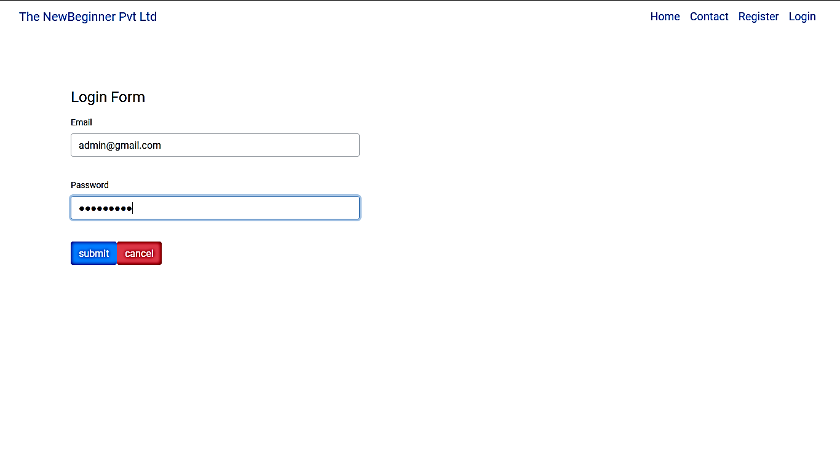

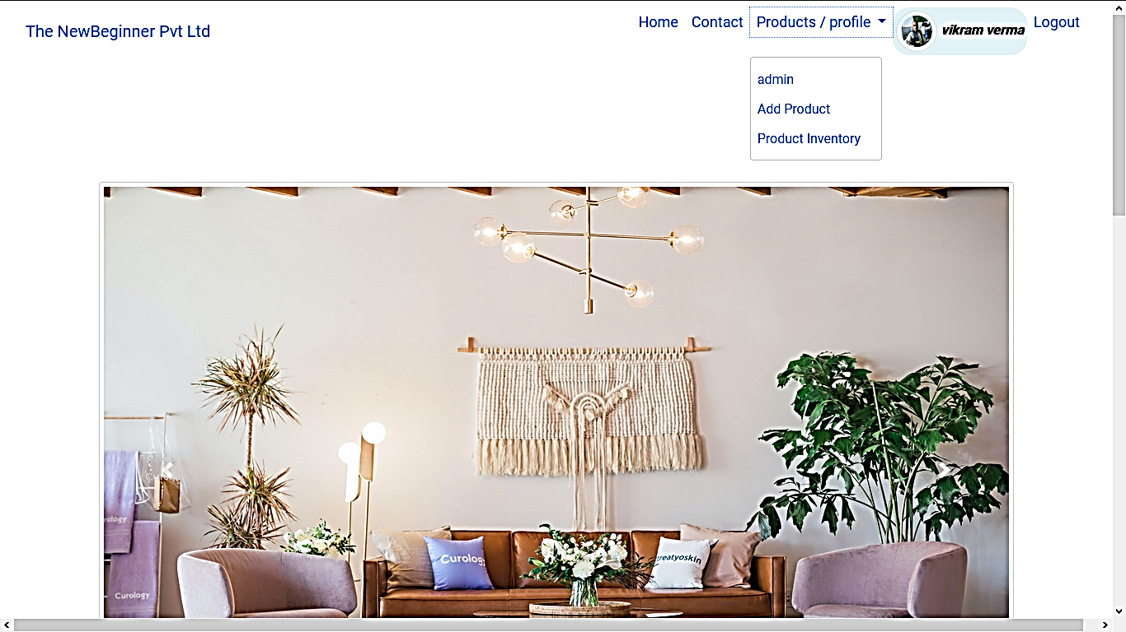

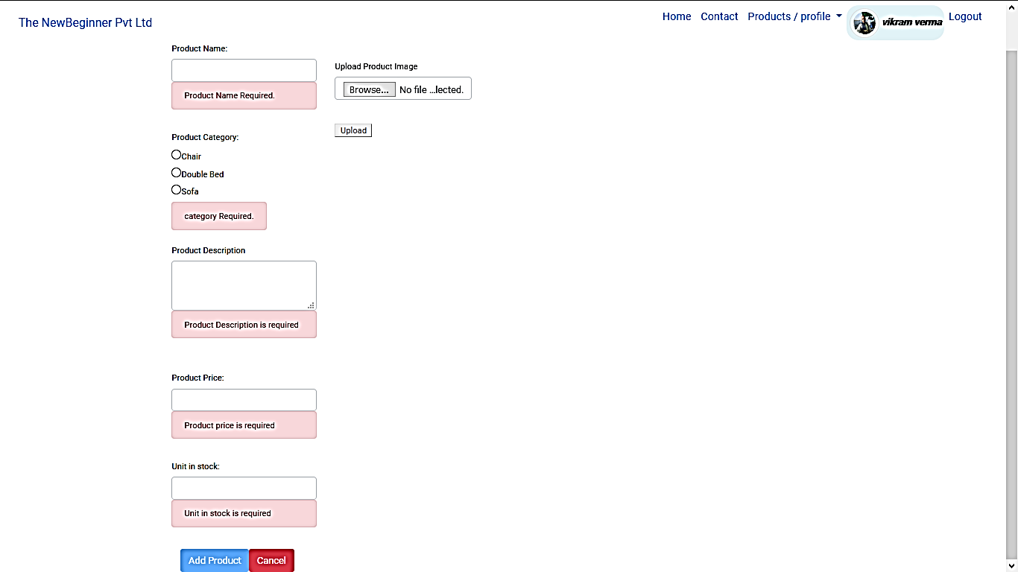

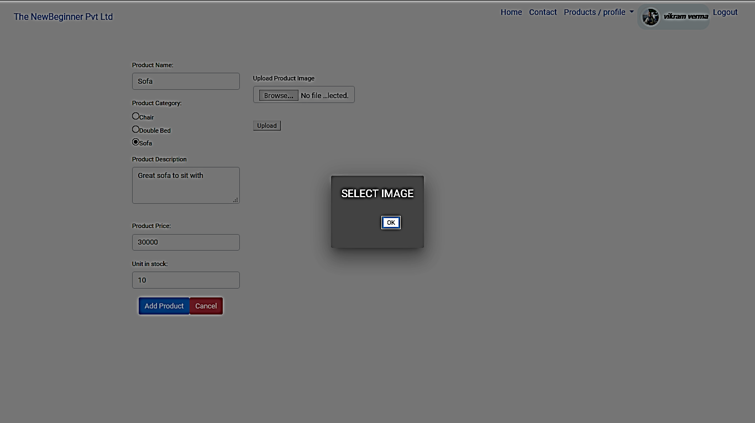

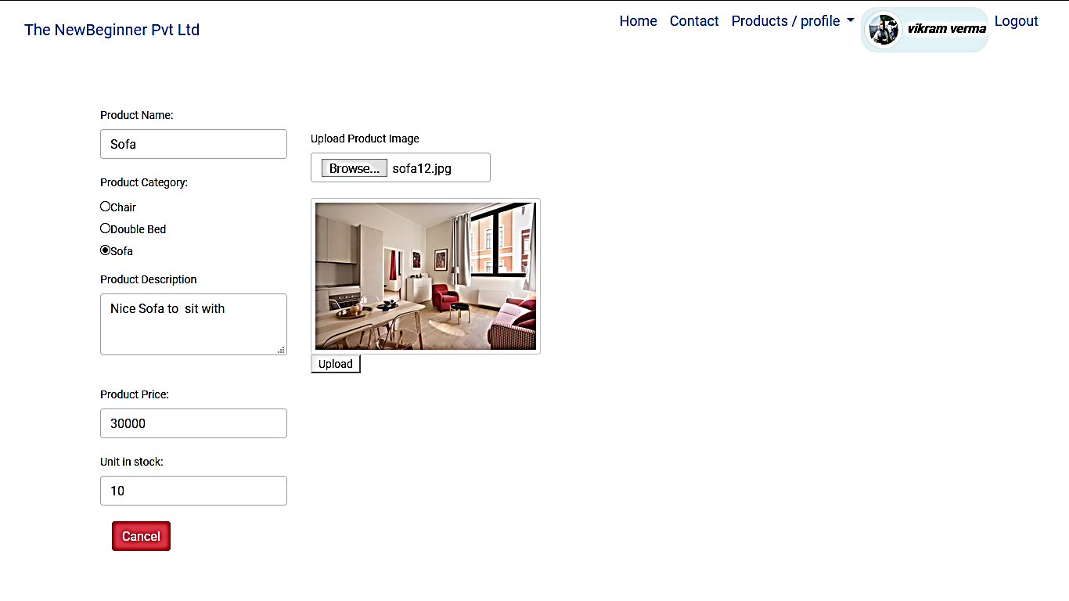

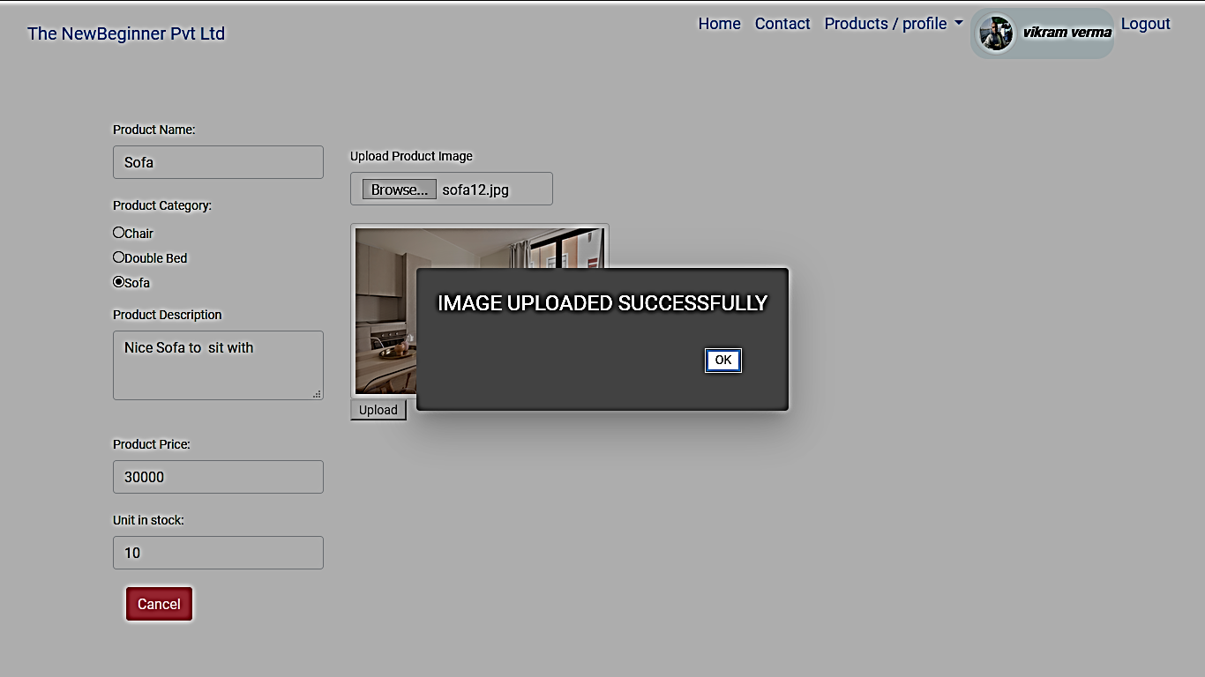

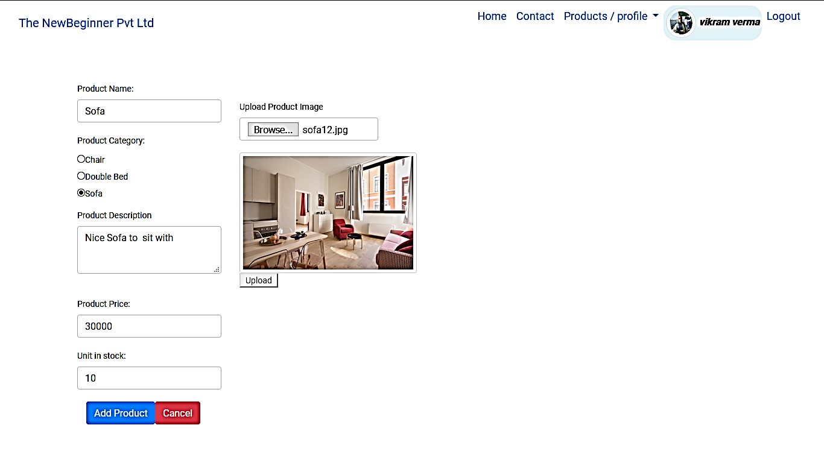

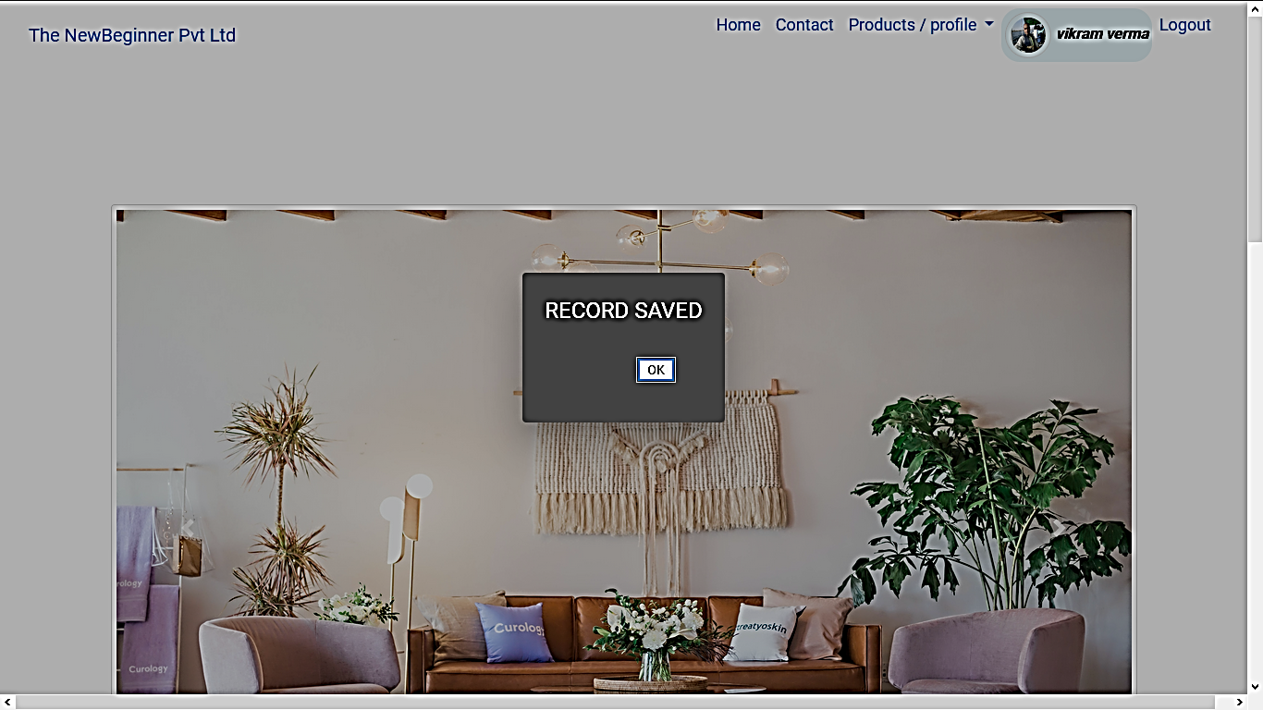

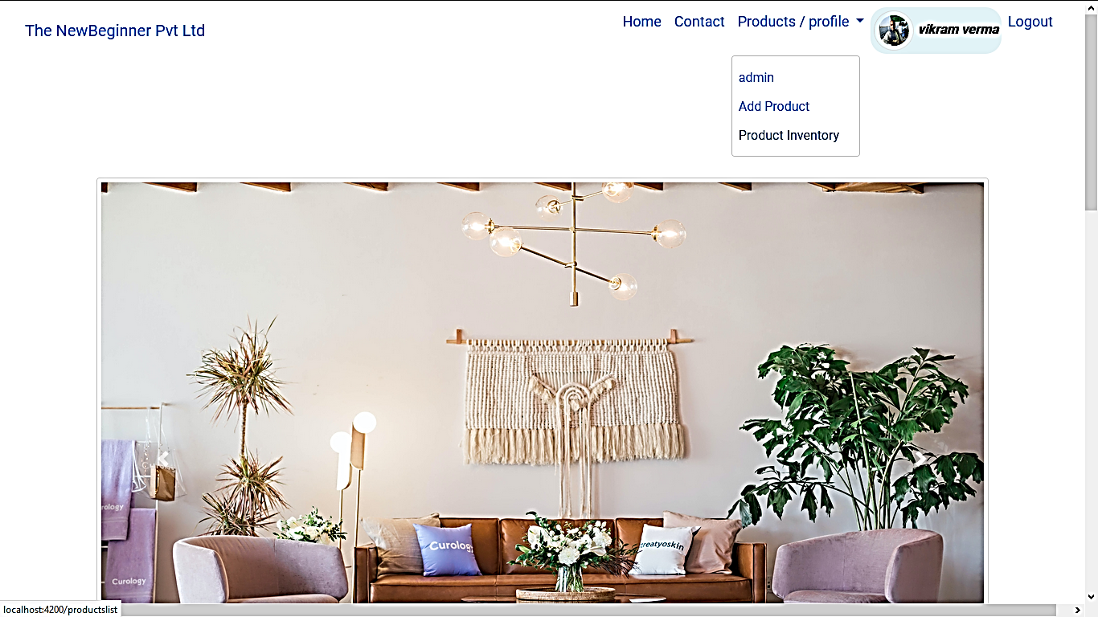

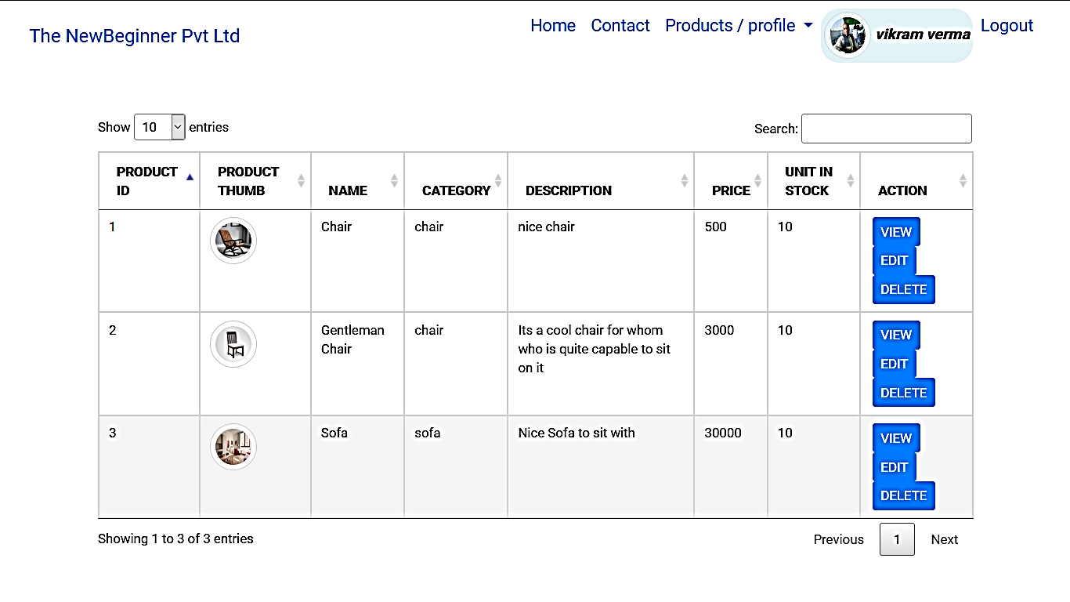

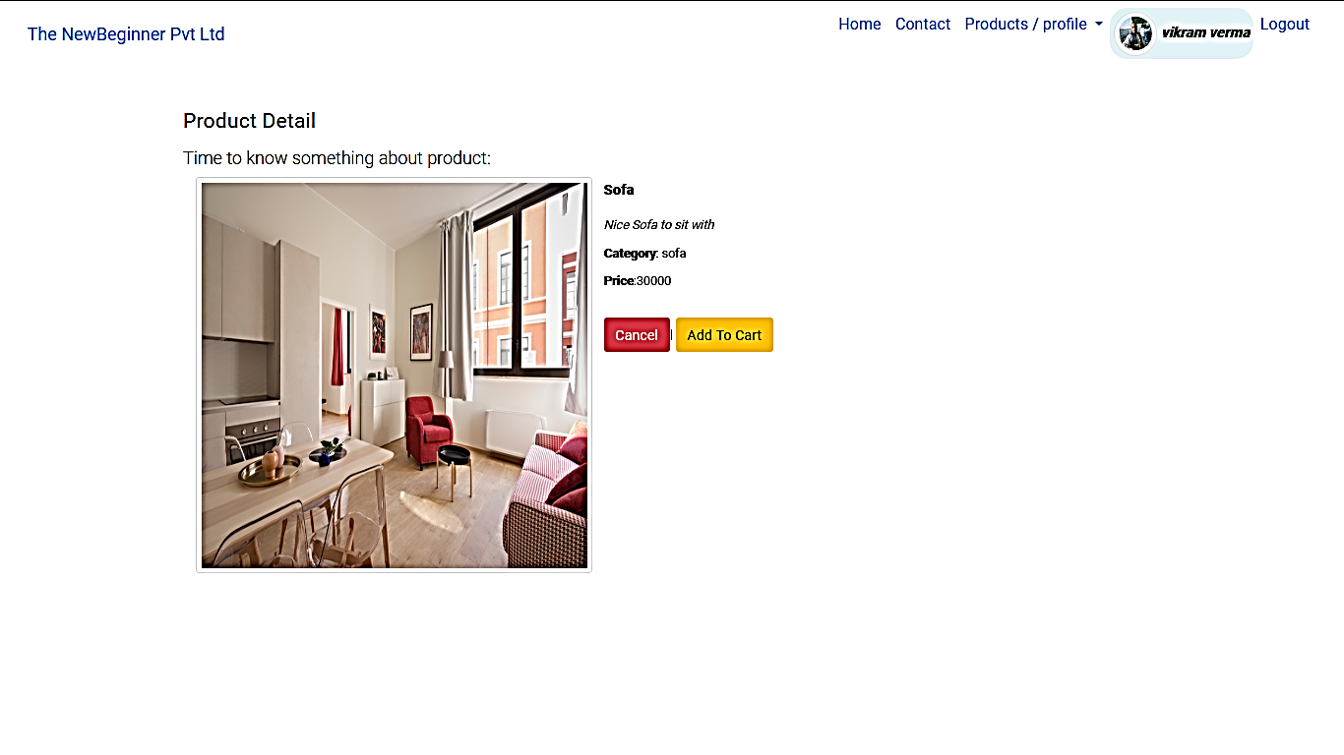

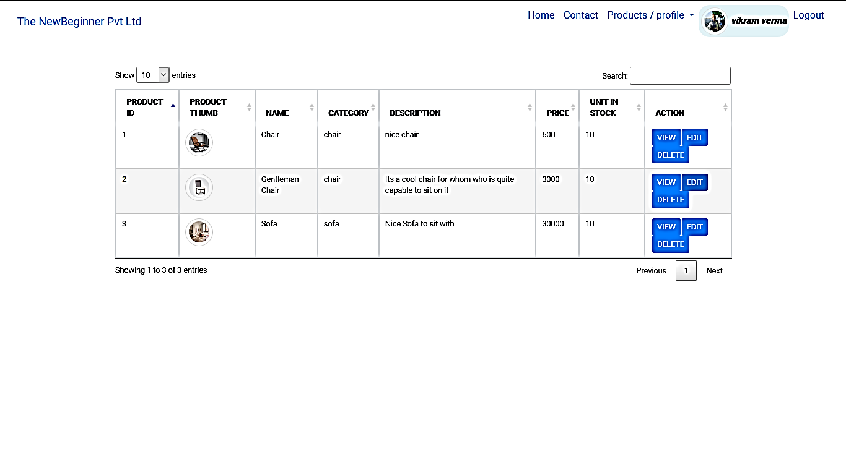

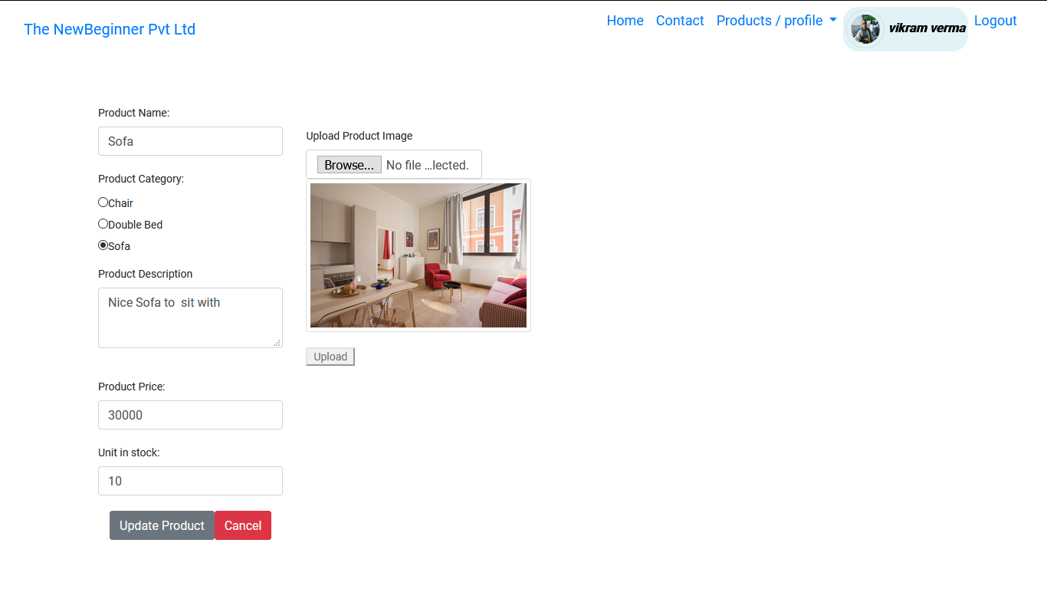

Like that product can be updated and deleted as well.

-----------------------

User Section Short Pictorial Demo

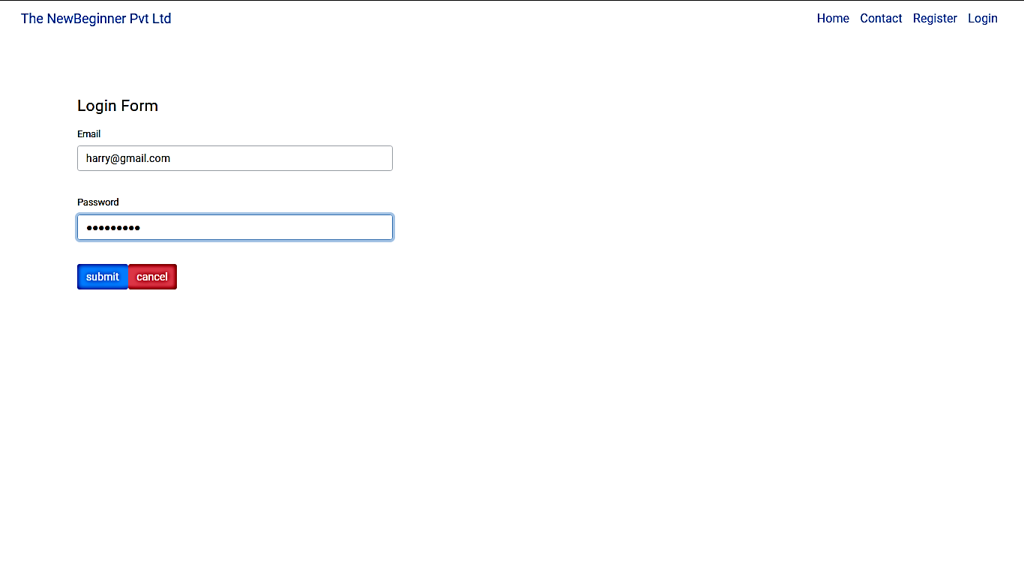

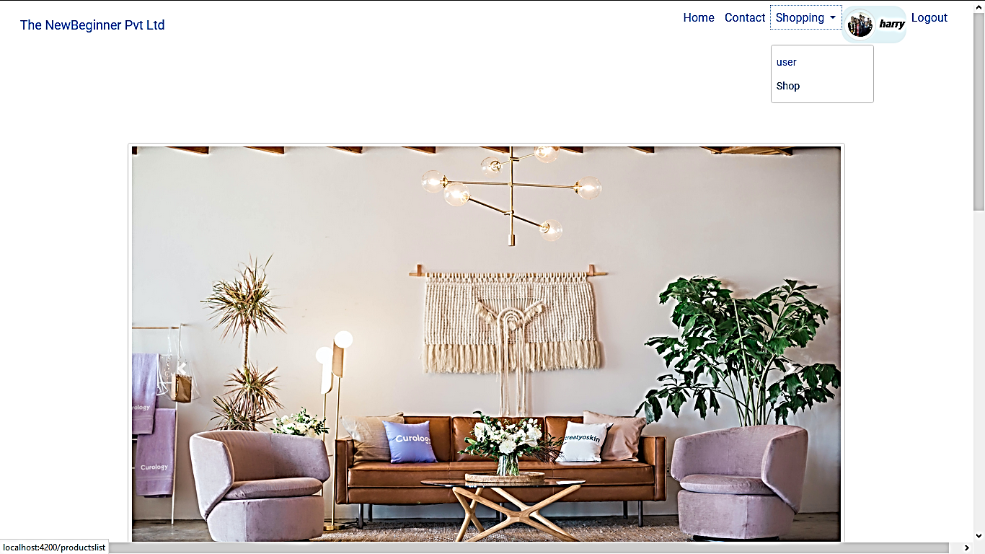

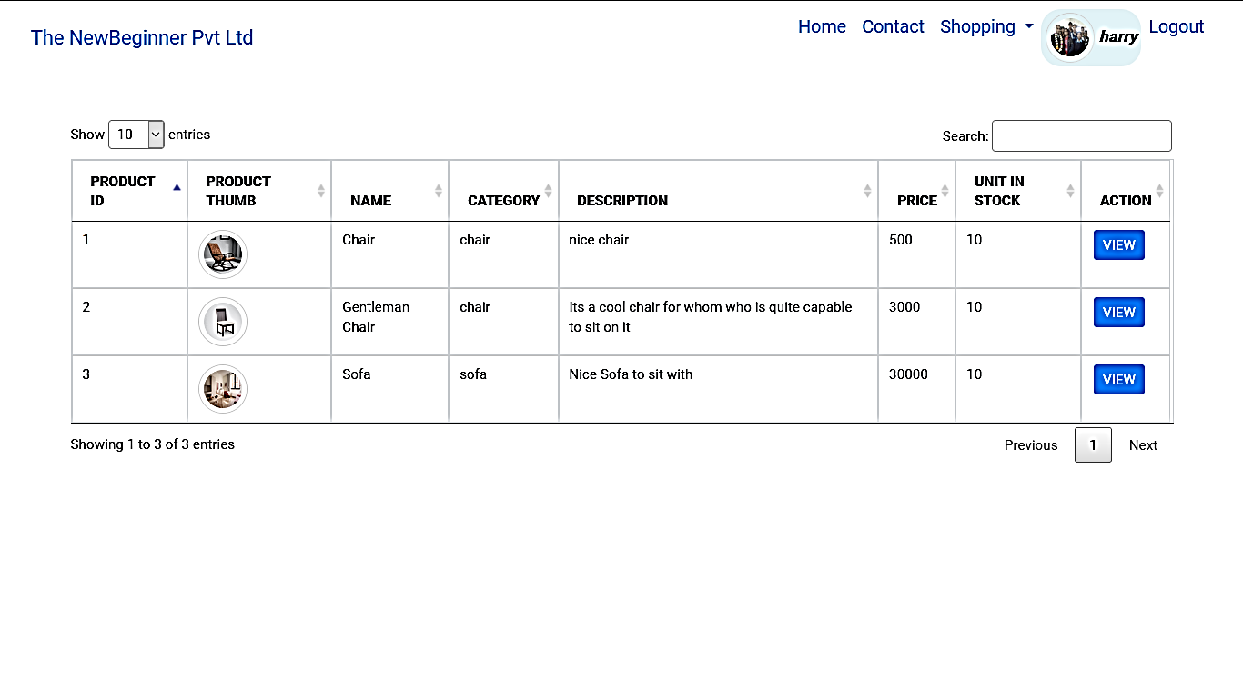

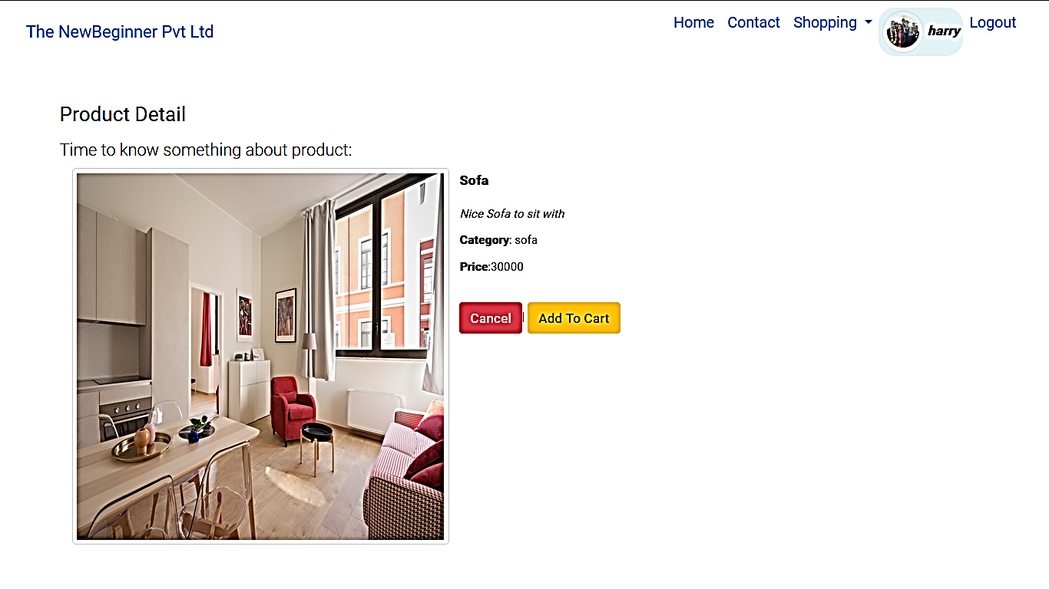

Kindly follow project 3 screen shots for rest of the project, some are:



